Software Design Document (SDD)

Lab Assignment 02: TIM (Timers)

GPIO Driver — STM32F411RE/F446RE

Module | GPIO Driver
Version | 1.0.0
Team | Adalberto Aguirre  Mauricio Vela  Steven McClellan
Date | 27/04/2026
Institution | CETYS Universidad

1. Introduction

1.1 Purpose
This document describes the design and architecture of the TIM (Timer) driver module for the STM32F411RE microcontroller, as developed in Lab Assignment 02. It provides details on data structures, hardware register mappings, control flow, and the public API to guide implementation and testing of higher-level modules that rely on timer functionality — specifically the Timer delay module and the PWM module.

1.2 Scope
The TIM driver is a low-level software component for the STM32F411RE embedded system. It abstracts the TIM hardware registers and provides a clean, validated API for higher-level modules to initialize timers, configure time intervals or frequencies, control the counter, configure capture/compare channels for PWM or event triggering, and wait for timer overflow events. The driver supports TIM1 through TIM11 (excluding TIM6, TIM7, TIM8 which are not present on the F411RE).

1.3 Definitions and Acronyms
Term | Definition
TIM | Timer peripheral in STM32 microcontrollers.
PSC | Prescaler register — divides the input clock to produce the timer tick frequency.
ARR | Auto-Reload Register — defines the timer period. Counter resets when CNT reaches ARR.
CCR | Capture/Compare Register — threshold value for compare operations and PWM duty cycle.
CCMR | Capture/Compare Mode Register — configures the operating mode of each channel (input capture, output compare, PWM).
CCER | Capture/Compare Enable Register — enables or disables individual compare channels.
CR1 | Control Register 1 — contains CEN (counter enable) and ARPE (auto-reload preload enable) bits.
SR | Status Register — contains UIF (Update Interrupt Flag), set on counter overflow.
EGR | Event Generation Register — writing UG bit forces an update event to reload PSC and ARR shadow registers.
UIF | Update Interrupt Flag — bit 0 of SR, set when counter overflows (reaches ARR).
PWM | Pulse Width Modulation — signal generated by comparing CNT against CCR in PWM mode.
APB1 | Advanced Peripheral Bus 1 — TIM2–TIM5 are clocked from APB1.
APB2 | Advanced Peripheral Bus 2 — TIM1, TIM9–TIM11 are clocked from APB2.
CMSIS | Cortex Microcontroller Software Interface Standard — provides TIM_TypeDef register definitions.
SRS | Software Requirements Specification — authoritative source for functional requirements.
SDD | Software Design Document — this document.

1.4 Requirements Traceability
The table below maps each functional requirement from the TIM SRS to the corresponding public API function implemented in this driver.

Req. ID | Function | Requirement Statement
FR-1 | tim_init() | The system shall configure all TIM peripherals to a default state.
FR-2 | tim_initTimer() | The system shall enable clocking and configure the specified timer.
FR-3 | tim_setTimerMs() | The system shall calculate PSC and ARR values to achieve the requested interval in milliseconds.
FR-4 | tim_setTimerFreq() | The system shall calculate PSC and ARR values to achieve the requested frequency in Hz.
FR-5 | tim_enableTimer() | The system shall start the counter and generate update events.
FR-6 | tim_disableTimer() | The system shall stop the specified timer from counting and generating events.
FR-7 | tim_waitTimer() | The system shall block execution until the timer reaches its overflow/update event.
FR-8 | tim_setTimerCompareChannelValue() | The system shall trigger a compare event when the counter reaches the threshold.
FR-9 | tim_setTimerCompareChannelMode() | The system shall allow configuration of compare modes using register settings.
FR-10 | tim_enableTimerCompareChannel() | The system shall activate the specified channel to generate compare events.
FR-11 | tim_disableTimerCompareChannel() | The system shall deactivate the specified channel, preventing compare events.

Non-functional requirements applicable to this driver:
- NFR-1: The driver shall be lightweight and efficient — no dynamic memory allocation, no HAL middleware.
- NFR-2: The driver shall provide error handling for invalid timer or channel inputs, returning non-zero error codes.
- NFR-3: The driver shall meet real-time performance constraints for embedded operation.

2. System Architecture

2.1 High-Level Design
The TIM driver follows the same three-layer architecture established in Lab 01. The driver sits between the application-level Timer and PWM modules and the hardware registers.

Layer | Files | Description
Application Layer | main.c | Integrates led, timer, and pwm modules. No direct register access.
Driver Layer | timer.c / timer.hpwm.c / pwm.h | Hardware abstraction for delay and PWM. Use exclusively the TIM driver API and GPIO driver API.
TIM Driver Layer | SRS_TIM_DRIVER.c / .h | Sole layer with direct TIM register access. Implements all eleven FR functions.
Hardware Layer | STM32F411RE Registers | TIM_TypeDef registers mapped at APB1/APB2 peripheral bus addresses.

2.2 Class Diagram
Figure 1 shows the static structure of the TIM driver and its relationship to the Timer and PWM modules.

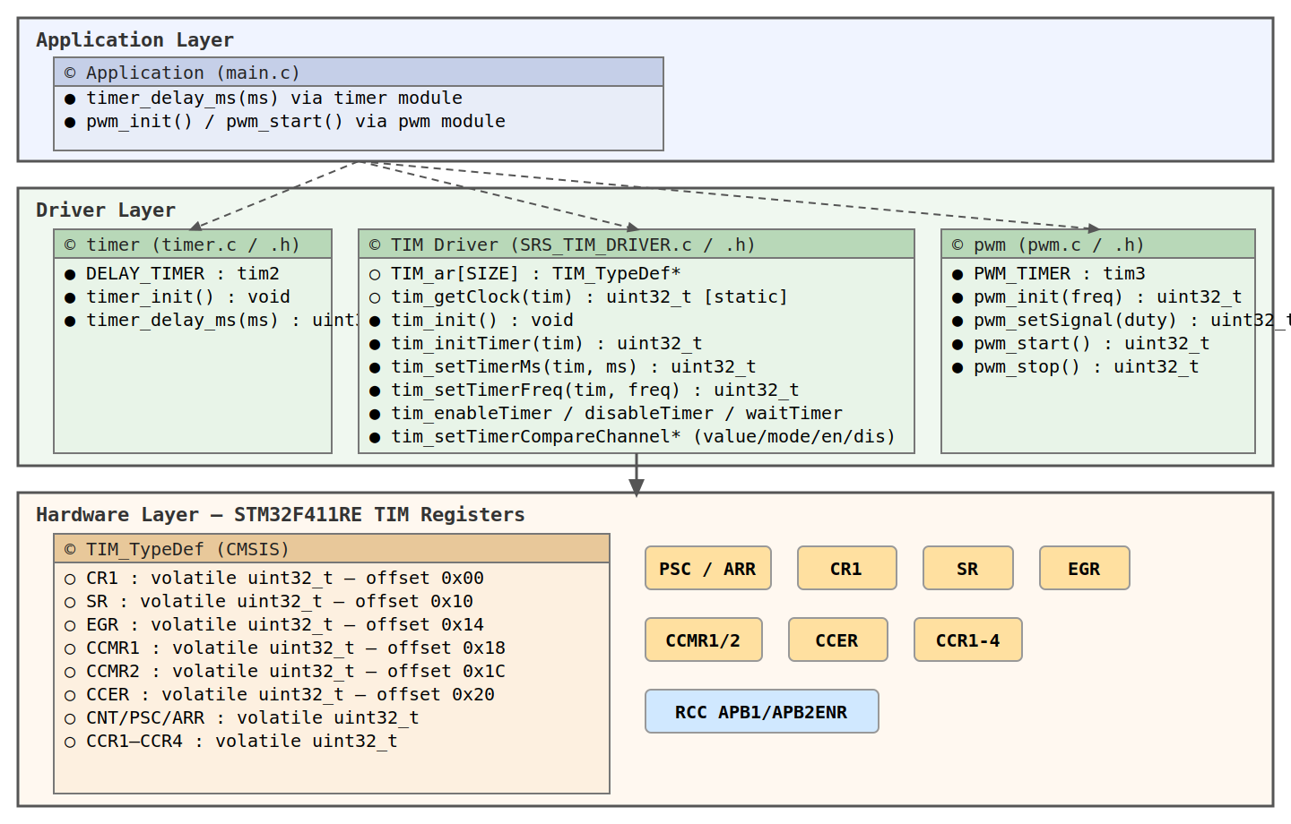
Figure 1. Class Diagram — TIM Driver

2.3 Module Interfaces
- Public API: All user-callable functions are declared in SRS_TIM_DRIVER.h.
- Internal implementation: TIM_ar[] array and tim_getClock() static helper are defined in SRS_TIM_DRIVER.c and not visible externally.
- Dependencies: CMSIS TIM_TypeDef and RCC_TypeDef register definitions only. No HAL middleware.
- Hardware dependencies: TIM peripherals on APB1 and APB2 buses; RCC APB1ENR and APB2ENR for clock gating.

2.4 Module Behavior
The following diagrams describe the behavioral design of each public function. Each function is covered by a sequence diagram and an activity diagram.

tim_init — Global Initialization (FR-1)
Populates TIM_ar[] with CMSIS base addresses for TIM1 through TIM11. Must be called before any other TIM driver function.

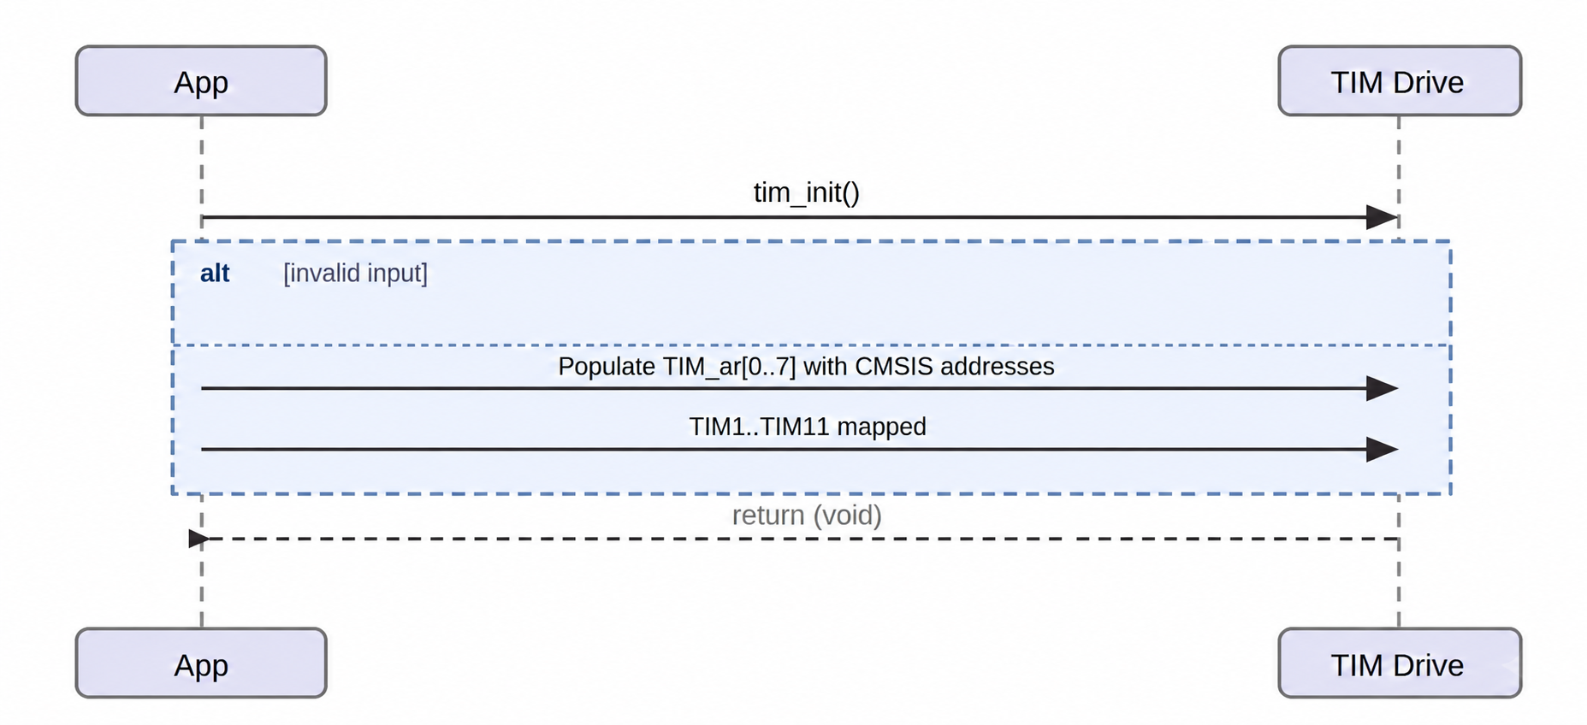
Figure 2. Sequence Diagram — tim_init
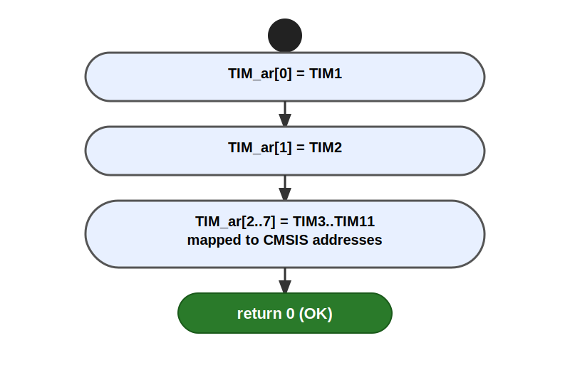
Figure 3. Activity Diagram — tim_init

tim_initTimer — Per-Timer Clock Enable (FR-2)
Validates the timer parameter then enables its peripheral clock via RCC->APB1ENR or RCC->APB2ENR depending on the timer. APB1 timers: TIM2–TIM5. APB2 timers: TIM1, TIM9–TIM11.

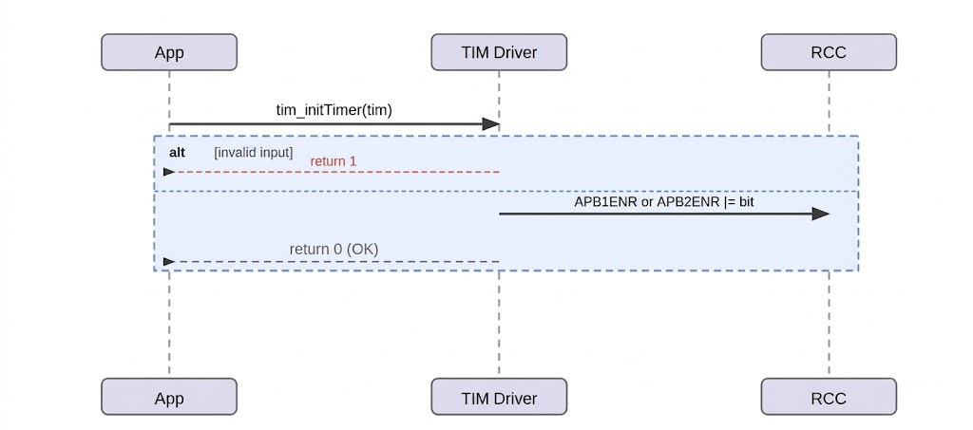
Figure 4. Sequence Diagram — tim_initTimer
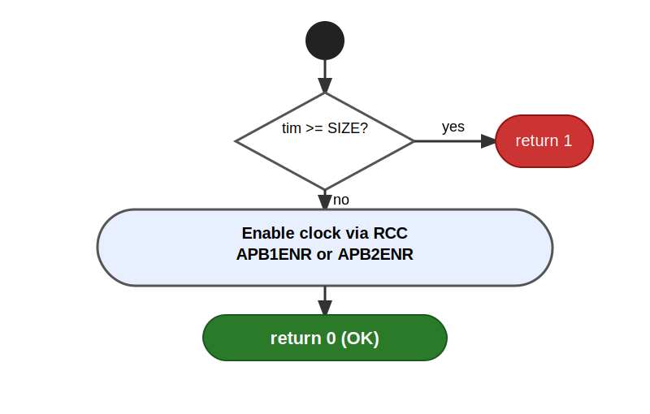
Figure 5. Activity Diagram — tim_initTimer

tim_setTimerMs — Millisecond Interval Configuration (FR-3)
Configures PSC and ARR to produce a 1 ms tick and a period of ms_duration milliseconds. PSC = (CLK/1000) - 1 gives one tick per millisecond. ARR = ms_duration - 1 causes overflow after the requested number of ticks. For 16 MHz HSI: PSC = 15999.

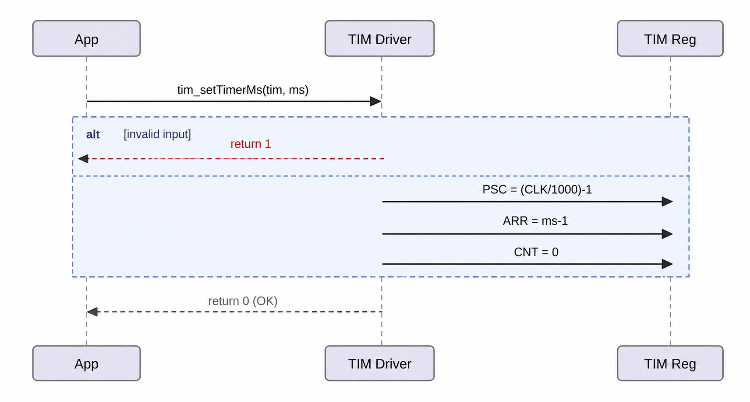
Figure 6. Sequence Diagram — tim_setTimerMs
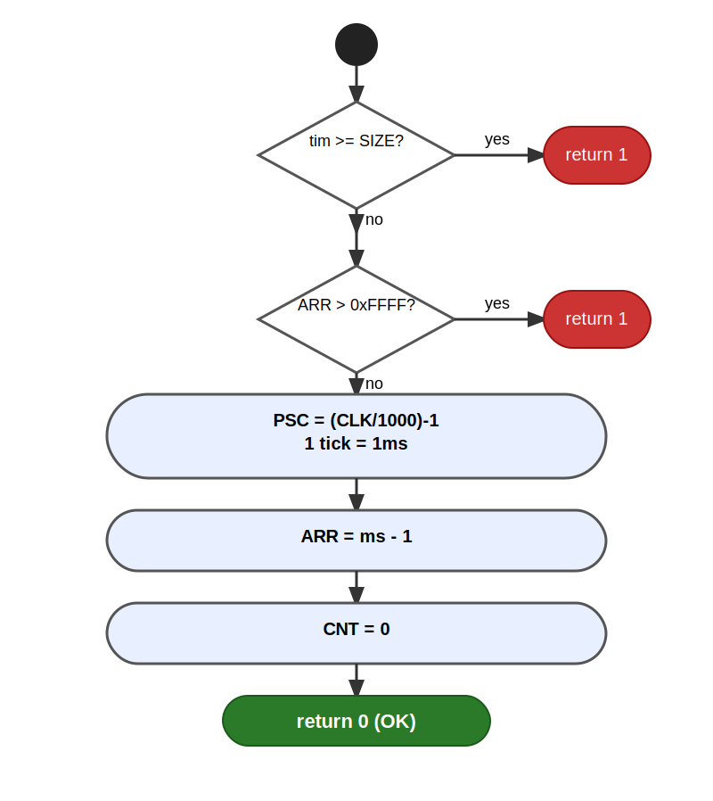
Figure 7. Activity Diagram — tim_setTimerMs

tim_setTimerFreq — Frequency Configuration (FR-4)
Calculates PSC and ARR to achieve a target frequency. ticks = CLK / freq. For 32-bit timers (TIM2, TIM5): PSC = 0, ARR = ticks - 1. For 16-bit timers: PSC = ceil(ticks/65536), ARR = ticks/(PSC+1) - 1. Triggers an EGR update event to load shadow registers immediately.

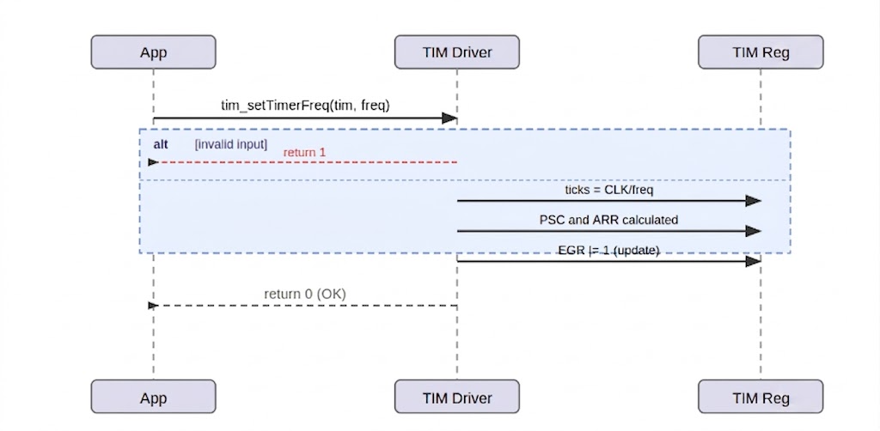
Figure 8. Sequence Diagram — tim_setTimerFreq
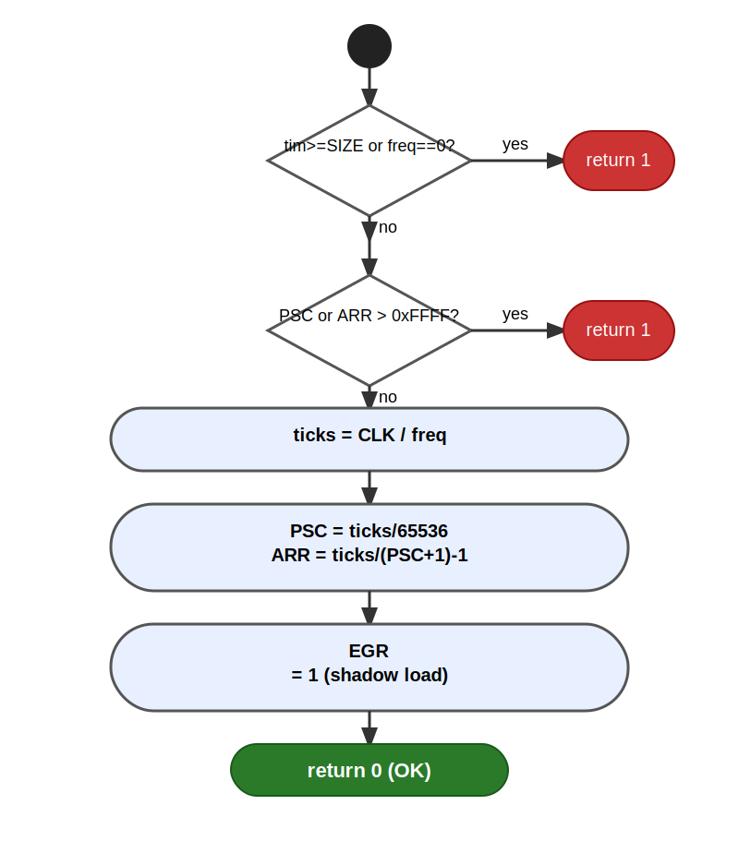
Figure 9. Activity Diagram — tim_setTimerFreq

tim_enableTimer / tim_disableTimer (FR-5, FR-6)
tim_enableTimer resets CNT to 0, forces an EGR update to load PSC/ARR into their active registers, then sets CR1.CEN to start counting. tim_disableTimer clears CR1.CEN to stop the counter.

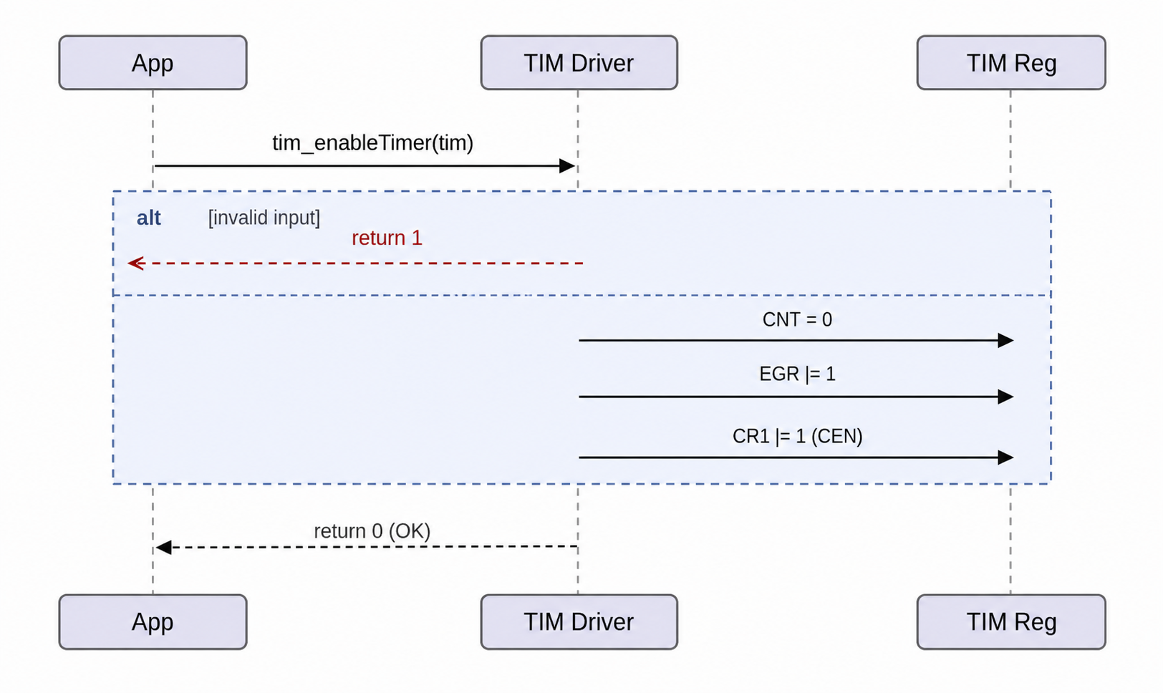
Figure 10. Sequence Diagram — tim_enableTimer
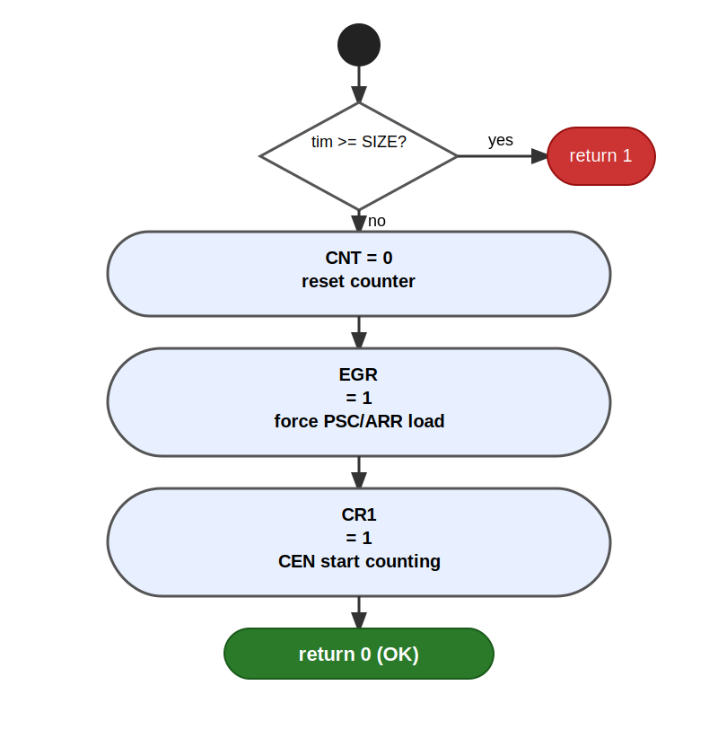
Figure 11. Activity Diagram — tim_enableTimer
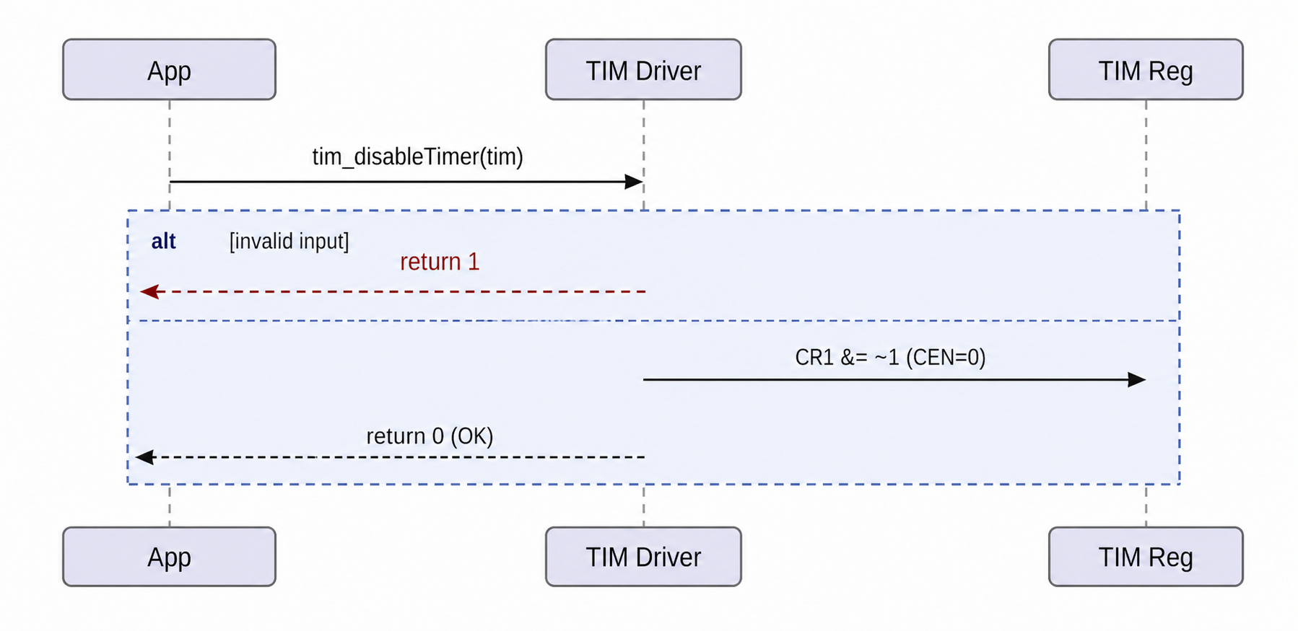
Figure 12. Sequence Diagram — tim_disableTimer

tim_waitTimer — Blocking Wait for Overflow (FR-7)
Polls the UIF bit in the SR register until it is set, indicating a counter overflow. A timeout counter (50,000,000 iterations) prevents deadlocks if the timer fails to overflow. After detecting UIF, the flag is cleared to prepare for the next cycle. The function fails immediately if the timer is not enabled (CR1.CEN = 0).

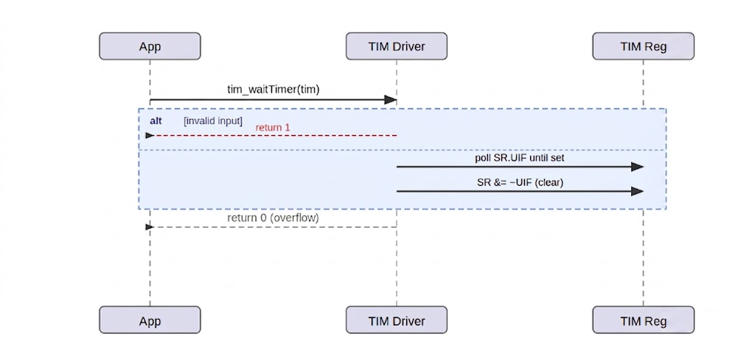
Figure 13. Sequence Diagram — tim_waitTimer
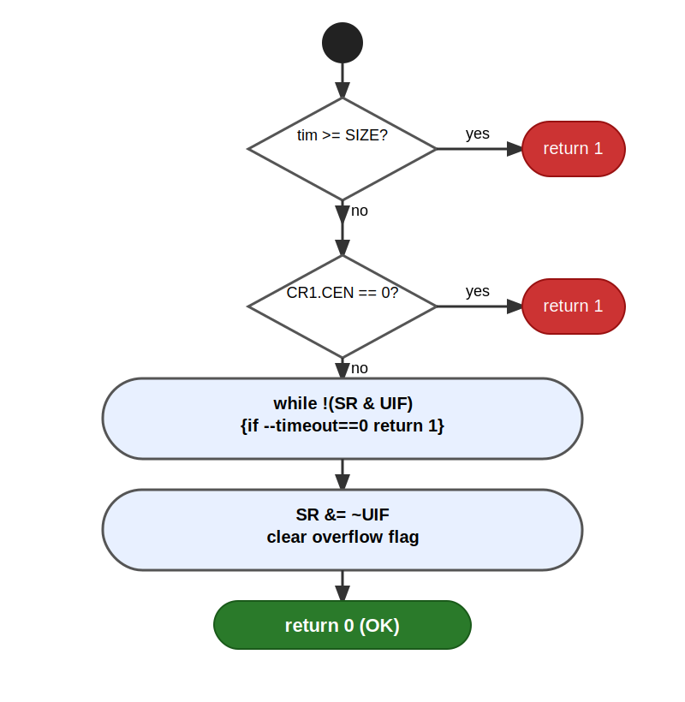
Figure 14. Activity Diagram — tim_waitTimer

Compare Channel Functions (FR-8 to FR-11)
These four functions configure and control capture/compare channels for PWM generation. tim_setTimerCompareChannelValue() writes to CCR1–CCR4. tim_setTimerCompareChannelMode() writes the 3-bit OC1M field in CCMR1/CCMR2 and enables output compare preload (OC1PE). tim_enableTimerCompareChannel() sets CCER.CCxE. tim_disableTimerCompareChannel() clears CCER.CCxE. All functions validate timer and channel ranges; channels 1–4 are valid for general-purpose timers.

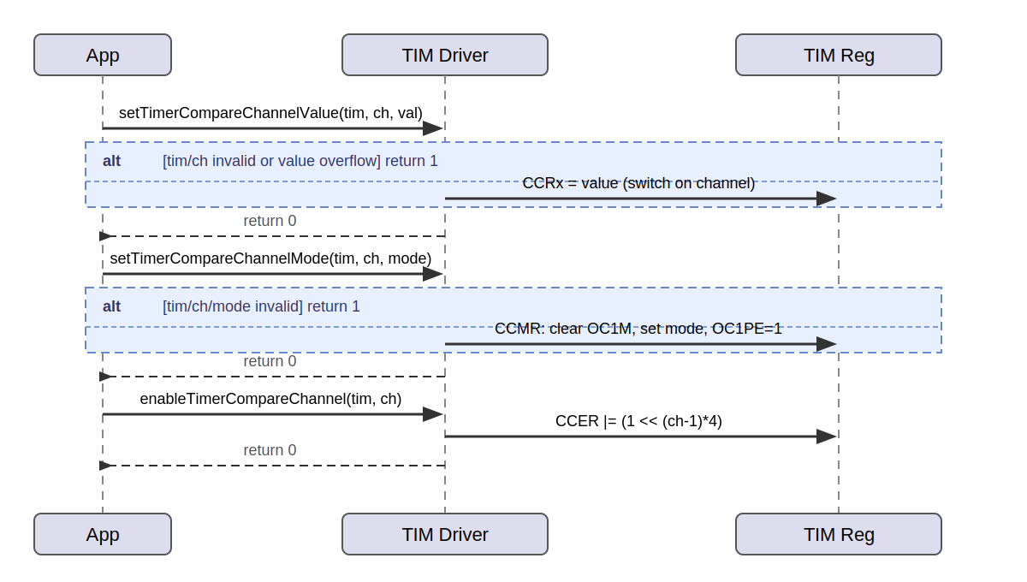
Figure 15. Sequence Diagram — Compare Channel Functions (setValue, setMode, enable)

Driver State Machine
Figure 16 describes the overall lifecycle of the TIM driver from system reset through initialization to running operation.

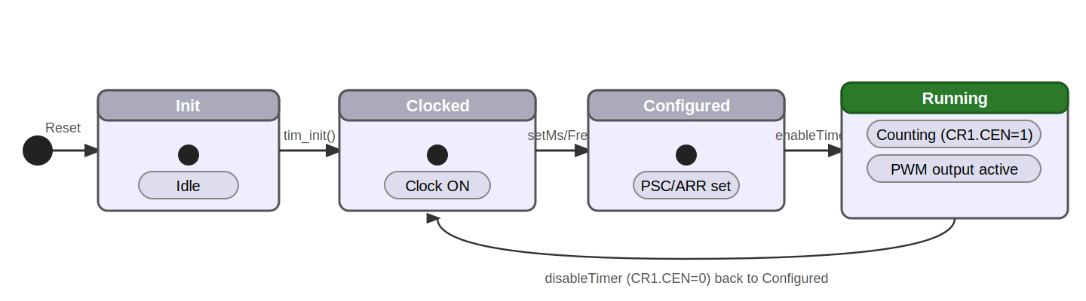
Figure 16. State Diagram — TIM Driver Lifecycle

3. TIM Driver
The TIM driver for the STM32F411RE is implemented in two files: SRS_TIM_DRIVER.h (public declarations) and SRS_TIM_DRIVER.c (implementation). The driver operates entirely through direct hardware register access via CMSIS TIM_TypeDef pointers.

3.1 Internal Data Structures
TIM_ar[SIZE]:
A global array of TIM_TypeDef* pointers that maps each tim_g enum value to its CMSIS base address. All functions resolve a timer by indexing this array — O(1), no conditional branching.

tim_getClock() — static helper:
Returns the APB clock frequency for a given timer. On the STM32F411RE NUCLEO-64 with default HSI configuration (no PLL), all timers run at 16 MHz. APB1 timers (TIM2–TIM5) and APB2 timers (TIM1, TIM9–TIM11) both return 16,000,000.

3.2 Initialization Flow
tim_init (FR-1) populates TIM_ar[] with CMSIS base addresses. tim_initTimer (FR-2) enables the clock for a single timer by writing to the appropriate RCC enable register bit. Timer clocks are off by default after reset — enabling the clock is mandatory before any register access.

3.3 Timing Configuration
tim_setTimerMs configures a timer for a specific millisecond interval by setting PSC to produce 1 kHz ticks and ARR to count the requested number of ticks. tim_setTimerFreq configures a timer for a specific output frequency by computing PSC and ARR from the formula: ticks = CLK/freq, then distributing ticks across PSC and ARR while respecting the 16-bit register limit. An EGR update event is triggered to load the shadow registers immediately.

3.4 Counter Control
tim_enableTimer resets the counter, forces a register update via EGR, and sets CR1.CEN = 1. tim_disableTimer clears CR1.CEN = 0. tim_waitTimer polls SR.UIF with a timeout counter, clears the flag on detection, and returns. The non-atomic nature of tim_waitTimer (read-poll-clear) is safe in the single-threaded polling context of this lab.

3.5 Compare Channel Configuration
The compare channel functions implement the PWM configuration sequence. tim_setTimerCompareChannelMode writes the OC1M mode field in CCMR1 or CCMR2 (3 bits at shift position 4 or 12 depending on channel) and enables the output compare preload bit (OC1PE at shift-1). tim_setTimerCompareChannelValue writes the CCR register for the target channel. tim_enableTimerCompareChannel sets CCER.CCxE where x = (channel-1)*4.

4. Application Programming Interfaces

4.1 Data Types and Macros

Enumerations
tim_g: Identifies each supported timer. SIZE is a sentinel value used for bounds validation.

Enumerator | Value | Definition
tim1 | 0 | TIM1 — APB2, 16-bit advanced timer
tim2 | 1 | TIM2 — APB1, 32-bit general purpose
tim3 | 2 | TIM3 — APB1, 16-bit general purpose
tim4 | 3 | TIM4 — APB1, 16-bit general purpose
tim5 | 4 | TIM5 — APB1, 32-bit general purpose
tim9 | 5 | TIM9 — APB2, 16-bit general purpose
tim10 | 6 | TIM10 — APB2, 16-bit general purpose
tim11 | 7 | TIM11 — APB2, 16-bit general purpose
SIZE | 8 | Sentinel — boundary validation; not a valid timer.

4.2 Error Codes
Code | Value | Definition
0 | 0 | Operation completed successfully.
1 | 1 | Invalid timer (>= SIZE), invalid channel (not 1–4), invalid mode (> 7), or overflow detected.

4.3 Function Definitions

tim_init
Function Name | tim_init
Syntax | void tim_init(void)
Parameters (in) | None
Parameters (inout) | None
Parameters (out) | None
Return value | void
Description | Populates TIM_ar[] with CMSIS base addresses for TIM1 through TIM11. Must be called before any other TIM driver function.
Constraints | No parameter validation. Does not enable any clocks.
Available via | SRS_TIM_DRIVER.h

tim_initTimer
Function Name | tim_initTimer
Syntax | uint32_t tim_initTimer(tim_g tim)
Parameters (in) | tim: tim_g — target timer.
Parameters (inout) | None
Parameters (out) | None
Return value | 0 on success. 1 if tim >= SIZE.
Description | Enables the peripheral clock for the specified timer by setting the corresponding bit in RCC->APB1ENR (TIM2–TIM5) or RCC->APB2ENR (TIM1, TIM9–TIM11).
Constraints | tim_init() must be called first. Does not configure PSC, ARR, or mode.
Available via | SRS_TIM_DRIVER.h

tim_setTimerMs
Function Name | tim_setTimerMs
Syntax | uint32_t tim_setTimerMs(tim_g tim, uint32_t ms_duration)
Parameters (in) | tim: tim_g — target timer.
Parameters (in) | ms_duration: uint32_t — delay in milliseconds.
Parameters (inout) | None
Parameters (out) | None
Return value | 0 on success. 1 if tim invalid or ARR overflow for 16-bit timers.
Description | Sets PSC = (CLK/1000) - 1 for 1 ms ticks, ARR = ms_duration - 1 for the requested interval, and resets CNT = 0. At 16 MHz: PSC = 15999.
Constraints | Clock must be enabled. For 16-bit timers (not tim2/tim5), ms_duration must not exceed 65536.
Available via | SRS_TIM_DRIVER.h

tim_setTimerFreq
Function Name | tim_setTimerFreq
Syntax | uint32_t tim_setTimerFreq(tim_g tim, uint32_t freq)
Parameters (in) | tim: tim_g — target timer.
Parameters (in) | freq: uint32_t — desired frequency in Hz. Must be > 0.
Parameters (inout) | None
Parameters (out) | None
Return value | 0 on success. 1 if tim or freq invalid, or PSC/ARR overflow.
Description | Calculates ticks = CLK/freq, then computes PSC and ARR. Triggers EGR update to load shadow registers.
Constraints | Clock must be enabled. freq must be achievable within the 16-bit register limits for 16-bit timers.
Available via | SRS_TIM_DRIVER.h

tim_enableTimer
Function Name | tim_enableTimer
Syntax | uint32_t tim_enableTimer(tim_g tim)
Parameters (in) | tim: tim_g — target timer.
Parameters (inout) | None
Parameters (out) | None
Return value | 0 on success. 1 if tim >= SIZE.
Description | Resets CNT = 0, forces EGR update to load PSC/ARR into active registers, then sets CR1.CEN = 1 to start counting.
Constraints | PSC and ARR must be configured before calling.
Available via | SRS_TIM_DRIVER.h

tim_disableTimer
Function Name | tim_disableTimer
Syntax | uint32_t tim_disableTimer(tim_g tim)
Parameters (in) | tim: tim_g — target timer.
Parameters (inout) | None
Parameters (out) | None
Return value | 0 on success. 1 if tim >= SIZE.
Description | Clears CR1.CEN = 0, stopping the counter. Does not reset CNT or PSC/ARR.
Constraints | None.
Available via | SRS_TIM_DRIVER.h

tim_waitTimer
Function Name | tim_waitTimer
Syntax | uint32_t tim_waitTimer(tim_g tim)
Parameters (in) | tim: tim_g — target timer.
Parameters (inout) | None
Parameters (out) | None
Return value | 0 on overflow detected. 1 if tim invalid, timer not enabled, or timeout.
Description | Blocks execution by polling SR.UIF until set. Clears UIF on detection. Internal timeout of 50,000,000 iterations prevents deadlocks.
Constraints | Timer must be enabled (CR1.CEN = 1) before calling. Non-atomic — safe only in single-threaded context.
Available via | SRS_TIM_DRIVER.h

tim_setTimerCompareChannelValue
Function Name | tim_setTimerCompareChannelValue
Syntax | uint32_t tim_setTimerCompareChannelValue(tim_g tim, uint8_t channel, uint32_t value)
Parameters (in) | tim: tim_g — target timer.
Parameters (in) | channel: uint8_t — compare channel (1–4).
Parameters (in) | value: uint32_t — compare threshold (CCR value).
Parameters (inout) | None
Parameters (out) | None
Return value | 0 on success. 1 if tim, channel, or value invalid.
Description | Writes value to CCR1, CCR2, CCR3, or CCR4 depending on channel. For PWM: CCR = (ARR+1) * duty / 100.
Constraints | Channel must be in range 1–4. 16-bit overflow check applies for non-32-bit timers.
Available via | SRS_TIM_DRIVER.h

tim_setTimerCompareChannelMode
Function Name | tim_setTimerCompareChannelMode
Syntax | uint32_t tim_setTimerCompareChannelMode(tim_g tim, uint8_t channel, uint8_t mode)
Parameters (in) | tim: tim_g — target timer.
Parameters (in) | channel: uint8_t — compare channel (1–4).
Parameters (in) | mode: uint8_t — compare mode (0–7). Mode 6 = PWM Mode 1.
Parameters (inout) | None
Parameters (out) | None
Return value | 0 on success. 1 if tim, channel, or mode invalid.
Description | Writes the 3-bit OC1M field in CCMR1 (channels 1–2) or CCMR2 (channels 3–4) and enables output compare preload (OC1PE). For PWM Mode 1: mode = 6, output HIGH while CNT < CCR.
Constraints | Timer clock must be enabled. ARPE should be set in CR1 for buffered ARR.
Available via | SRS_TIM_DRIVER.h

tim_enableTimerCompareChannel
Function Name | tim_enableTimerCompareChannel
Syntax | uint32_t tim_enableTimerCompareChannel(tim_g tim, uint8_t channel)
Parameters (in) | tim: tim_g — target timer.
Parameters (in) | channel: uint8_t — compare channel (1–4).
Parameters (inout) | None
Parameters (out) | None
Return value | 0 on success. 1 if tim or channel invalid.
Description | Sets CCER.CCxE = 1 where bit position = (channel-1)*4. Activates the channel output on the corresponding GPIO pin.
Constraints | GPIO pin must already be configured in alternate function mode with the correct AF number.
Available via | SRS_TIM_DRIVER.h

tim_disableTimerCompareChannel
Function Name | tim_disableTimerCompareChannel
Syntax | uint32_t tim_disableTimerCompareChannel(tim_g tim, uint8_t channel)
Parameters (in) | tim: tim_g — target timer.
Parameters (in) | channel: uint8_t — compare channel (1–4).
Parameters (inout) | None
Parameters (out) | None
Return value | 0 on success. 1 if tim or channel invalid.
Description | Clears CCER.CCxE = 0, deactivating the channel output. The timer continues counting.
Constraints | None.
Available via | SRS_TIM_DRIVER.h

4.4 Internal Function Definitions
The TIM driver defines one internal (static) helper function not exposed in the header: tim_getClock(tim_g tim). This function returns the APB clock frequency for a given timer: 16,000,000 for all supported timers under the default 16 MHz HSI configuration of the STM32F411RE NUCLEO-64 board.

5. Future Enhancements
The following enhancements may be considered for future revisions of this TIM driver:

- Interrupt support: Add functions to enable the update interrupt (UIE in DIER) and configure the NVIC, enabling interrupt-driven delays instead of polling.
- Input capture mode: Add functions to configure channels in input capture mode for frequency or pulse-width measurement.
- DMA support: Add functions to trigger DMA transfers on compare events, enabling high-speed periodic data transfers without CPU intervention.
- PLL configuration: Add a system clock configuration module to run the CPU at higher frequencies (up to 100 MHz on F411RE), improving timer resolution.
- Center-aligned PWM mode: Add support for center-aligned (up-down counting) PWM mode for motor control applications.
- Dead-time insertion: For TIM1 (advanced timer), add complementary output and dead-time configuration for half-bridge motor driver control.
- One-pulse mode: Add support for CR1.OPM to generate a single pulse of configurable duration without software intervention.

